rVcenter
version 1.1
rVcenter is a command line tool that uses vCenter’s REST API to generate reports and remotely turn ON and OFF virtual machines. rVcenter is written in Python, it can be run from any platform that has Python installed on.

Installation on Linux
sudo cp rVcenter.py /usr/bin/rVcenter
sudo chmod +x /usr/bin/rVcenter

First Run and Security Considerations
rVcenter needs your vCenter connection parameters in order to run successfully. The connection parameters will be saved in : “.rvc/session.json”. I recommend that the parameter is deleted after running rVcenter.
$ rVcenter session
vCenter IP or FQDN: vcenter.example.com
Username: Your_vCenter_username
Password: **************

rVcenter Commands
$ rVcenter
===========================================================
Remote vCenter Ver 1.1
Created by: Anis Kochlef
Email: akochlef@gmail.com
!!! Use at your own risk, no warranty provided !!!
Usage:
/usr/bin/rVcenter session : Saves your vCenter connection parameters.
/usr/bin/rVcenter summary : Resource allocation summary report.
/usr/bin/rVcenter start <VM Name> : Starts the virtual machine.
/usr/bin/rVcenter stop <VM Name> : Stops the virtual machine.
/usr/bin/rVcenter inventory <text|csv|json> : Prints the full vCenter virtual machines inventory.
/usr/bin/rVcenter help : Prints this help.
===========================================================

Use rVcenter in Batch Mode
rVcenter can be used in batch mode to start or stop multiple virtual machines using a single command. In order to do so, create a new batch file and add in it the commands you need to run. the below screenshot is an example:
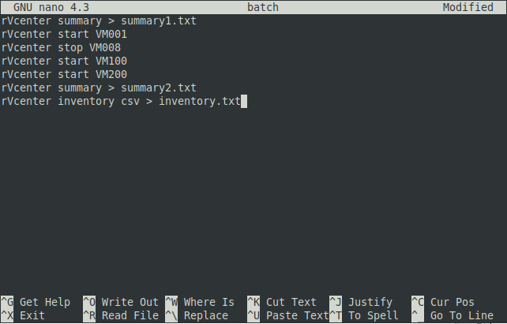
In order to run the batch file, issue the following commands:
$ chmod +x batch
$ ./batch

Future Developments
vCenter has a rich API that can be used to automate and speed up the virtual environment administration tasks; rVcenter can be easily and quickly extended to incorporate new functions. If you are interested in exploring the vCenter API capabilities or have any questions about rVcenter please do not hesitate to contact me.

